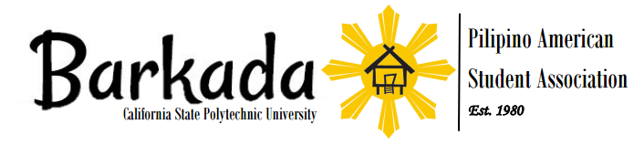
Membership Application 2016-2017
Return this form to any Executive Board Member It’s never too late to join!
Membership Fee- $25
PLEASE PRINT CLEARLY

NAME: ___________________________________________________________________________
^{Last} ^{First}
ADDRESS: ___________________________________________________________________________
^{Street} ^{apt/room#}
___________________________________________________________________________
^{City} ^{State} ^{Zip}
E-MAIL: _________________________________ BRONCO ID #: ___________________________

PHONE: (________)_______________________ BIRTHDAY: ___/_____/_______
^{mm} ^{dd yyyy}
STATUS (circle): Freshman Sophomore Junior Senior Graduate Alumnus

MAJOR(S): ___________________________________________________________________________

MINOR(S): ___________________________________________________________________________

SCHOOL (if not Cal Poly): _____________________________________________________________

SHIRT SIZE (circle): Small Medium Large X-Large

By providing us with the above information we will be able to contact you about upcoming events and activities. Please attend all Barkada general meeting to keep up with the latest news and updates. Barkada general meetings are every Thursday at 12PM.

As a member of Barkada, I promise to honor the Barkada
Constitution. I will be respectful to others, including other
members, when representing Barkada. I will do what I can to
have a positive impact on my community.

SIGNATURE ____________________________________

E-BOARD USE ONLY:
RECIEPT # ____________ CASH _______ CHECK _______ DATE ______/______/_______

RECEIVED BY _______________________

www.cppbarkada.org | Janet Dacumos : secretary@cppbarkada.org

